

**COVID PREVENTION SECURE**

**A Socially Relevant Project Report**

**Submitted to**

**Jawaharlal Nehru Technological University-A, Anantapur**

*In partial fulfilment of the requirements*

*For the award of the degree of*

**BACHELOR OF TECHNOLOGY**

In

**COMPUTER SCIENCE AND ENGINEERING**

**By**

**Project Batch – 26**

**Anjali B - 20AK5A0503**

**Balachandar P -20AK5A0504**

**Mounika T -20AK5A0505**

**Pavan Kalyan Y -20AK5A0506**

**Prathap P -20AK5A0507**

**GUIDED BY**

**Asst Prof.T Sai Kumar, M.Tech.,**



**DEPARTMENT OF COMPUTER SCIENCE AND ENGINEERING**

**ANNAMACHARYA INSTITUTE OF TECHNOLOGY AND SCIENCES::TIRUPATI**

**(AUTONOMOUS)**

Venkatapuram(V), Karakambadi(Po), Renigunta(M), Tirupati-517520, A.P.

**2019-2023**

**ANNAMACHARYA INSTITUTE OF TECHNOLOGY AND SCIENCES::TIRUPATI**

**(AUTONOMOUS)**

Venkatapuram(V), Karakambadi(Po), Renigunta(M), Tirupati-517520, A.P.

**DEPARTMENT OF COMPUTER SCIENCE AND ENGINEERING**



**CERTIFICATE**

Certified that this is a Bonafede record of the Project Report entitled, **“COVID PREVENTION SECURE ”, Done by B.Anjali, REG NO 20AK5A0503, P.BalaChandar, REG NO. 20AK5A0504, T.Mounika, REG NO. 20AK5A0505, Y.Pavan Kalyan, REG NO. 20AK5A0506, P.Prathap, REG NO. 20AK5A0507** Submitted to the faculty of Computer Science and Engineering, in partial fulfilment of the requirements for the Degree of BACHELOR OF TECHNOLOGY in Computer Science and Engineering from Jawaharlal Nehru Technological University-A, Anantapur during 2019- 2023.

|  |  |
| --- | --- |
| **Guide:** | **Head of The Department** |
| **T.Sai Kumar, M.Tech.** | **Ms. B. Rupa Devi, M.Tech (Ph.D.),** |
| **Assistant Professor,** | **Assistant Professor & HOD,** |
| **Dept of CSE,** | **Dept of CSE,** |
| **AITS, Tirupati.** | **AITS, Tirupati.** |

Date:

Place: Tirupati

**INTERNAL EXAMINER EXTERNAL EXAMINER**

ANNAMACHARYA INSTITUTE OF TECHNOLOGY AND SCIENCES

Venkatapuram(V), karakambadi(Po), Renigunta(M), Tirupati-517520,A.P

DEPARTMENT OF COMPUTER SCIENCE AND ENGINEERING



DECLARATION

We hereby declare that the project titled **“COVID PREVENTION SECURE ”** is a genuine project work carried out by us, in **B.Tech (Computer Science and Engineering)** degree course of **Jawaharlal Nehru Technology University-A, Anantapur** and has not been submitted to any other course or university for the award of our degree by us.

|  |  |
| --- | --- |
| **20AK5A0503 –** | **B.Anjali** |
| **20AK5A0504 –** | **P.BalaChandar** |
| **20AK5A0505 –** | **T.Mounika** |
| **20AK5A0506 –** | **Y.Pavan Kalyan** |
| **20AK5A0507 –** | **P.Prathap** |

## ACKNOWLEDGEMENT

The satisfaction that accompanies the successful completion of the task would be put incomplete without the mention of the people who made it possible, whose constant guidance and encouragement crown all the efforts with success.

We avail this opportunity to express our deep sense of gratitude and hearty thanks to **Mr. C. GANGI REDDY,** Hon’ble Secretary of AITS-Tirupati, for providing congenial atmosphere and encouragement.

We show gratitude to **Dr. C. NADHAMUNI REDDY**, **Principal** for having provided all the facilities and support.

We would like to thank **Ms. B. RUPA DEVI, Assistant Professor & HOD**, **Computer Science and Engineering** for encouragement at various levels of our Project.

We thankful to our guide **T.Sai Kumar Assistant Professor, Computer Science and Engineering** for his sustained inspiring guidance and cooperation throughout the process of this project. His wise counsel and suggestions were invaluable.

We thankful to Apssdc/IGDC and trainers **,** for training us on different platforms and for supporting us throughout our project.

We express our deep sense of gratitude and thanks to all the **Teaching** and **Non-Teaching Staff**

of our college who stood with us during the project and helped us to make it a successful venture.

We place highest regards to our **Parents**, **Friends** and **Well wishers** who helped a lot in making the report of this project.

|  |  |
| --- | --- |
| **20AK5A0503 –** | **B.Anjali** |
| **20AK5A0504 –** | **P.BalaChandar** |
| **20AK5A0505 –** | **T.Mounika** |
| **20AK5A0506 –** | **Y.Pavan Kalyan** |
| **20AK5A0507 –** | **P.Prathap** |

**CONTENTS**

ABSTRACT i

1. INTRODUCTION 1
2. EXISTING SYSTEM 2

2.1 DISADVATAGES

1. PROPOSED SYSTEM 3

3.1 ADVANTAGES

1. SYSTEM REQUIREMENTS 4

5.1 HARDWARE REQUIREMENTS

5.2 SOFTWARE REQUIREMENTS

1. FEATURES 5
2. SNAPSHOTS 7-20
3. FUTURE SCOPE 21
4. CONCLUSION 22

REFERENCES 23

**LIST OF FIGURES**

5.1-FEATURES 4

5.2-ARCHITECHTURE 5

6.1- Login Page 7

6.2- Create Account Prompt 7

6.3- Create Account 8

6.4- Show Confidential Text 8

6.5- Passwords Ambiguity 9

6.6- Account Created Popup 9

6.7- Login Page Credentials 10

6.8- Show Encrypted Password 10

6.9- Existed Account 11

6.10- Wrong Password 11

6.11- Password Incorrect Popup 12

6.12- Password Check 12

6.13- Storage Access 13

6.14- Assessment 14

6.15- Result with Green Indication 15

6.16- Result with Orange Indication 15

6.17- Result with Red Indication 15

6.18- Covid Vaccination Registration 16

6.19- Covid Test Registration 16

6.20- Health Analytics 17

6.21- Admin Login 18

6.22- Admin Logged In Popup 18

6.23- Reset Application 19

6.24- Contact Updation 19

6.25- Health Analytics in Admin view 20

6.26- After Contacts Updation 20

**ABSTRACT**

**Covid Prevention Secure**

There is a New Public health crisis threatening all over the world with the emergences and spread of COVID19. Due to this issue lack of People are losing their lives to overcome this problem we should prevent and secure Ourselves. Through an Assessment i.e., a person’s health status will be noticed, Here the three preventions of indicators are **Green** (Safe), **Orange** (A person in a family is affected due to covid and prevention for family members), **Red** (High Temperature, Cold, Body Pains, Headache). Through this Indications the person will be knowing his health status and get’s the doctor’s prescription and instructions, appointments. If requires, the patient will get the details of blood/plasma and oxygen availability. By this, the Effected person can be prevented and secured from Threats of Covid19.

**1.INTRODUCTION**

Coronaviruses (CoV) are a large family of viruses that cause illness ranging from the common cold to more severe diseases such as Middle East Respiratory Syndrome (MERS-CoV) and Severe Acute Respiratory Syndrome (SARS-CoV). A novel coronavirus (nCoV) is a new strain that has not been previously identified in humans. On 31 December 2019, WHO was informed of cases of pneumonia of unknown cause in Wuhan City, China. A novel coronavirus was identified as the cause by Chinese authorities on 7 January 2020 and was temporarily named “2019-nCoV”.

The primary mode of COVID-19 transmission is through respiratory droplets generated when an infected person coughs, sneezes, or talks. Droplets that settle on the eyes, nose, or mouth of a person in close proximity leads to the transmission of infection. It’s important to ensure that the infected person follows all the precautions laid down by covid prevention Secure.

**To prevent the spread of COVID-19**: Clean your hands often. Use soap and water, or an alcohol-based hand rub. Maintain a safe distance from anyone who is coughing or sneezing. Wear a mask when physical distancing is not possible. Don’t touch your eyes, nose or mouth. Cover your nose and mouth with your bent elbow or a tissue when you cough or sneeze. Stay home if you feel unwell. If you have a fever, cough and difficulty breathing, seek medical attention.

To overcome this problem, we should prevent and secure Ourselves. Through an Assessment i.e., a person’s health status will be noticed, Here the three preventions of indicators are Green (Safe), Orange (A person in a family is affected due to covid and prevention for family members), Red (High Temperature, Cold, Body Pains, Headache). Through this Indications the person

will be knowing his health status and gets the doctor’s prescription and instructions, appointments. If requires, the patient will get the details of blood/plasma and oxygen availability. By this, the Effected person can be prevented and secured from Threats of Covid19.

**2.EXISTING SYSTEM**

**2.1-DISADVANTAGES OF EXISTING SYSTEM**

* In existing system remaining people’s health status will not be visible.
* Blood and Oxygen details are not available in Existing system.
* Prescriptions are not available in Existing system.

**3.PROPOSED SYSTEM**

**3.1-ADVANTAGES OF PROPOSED SYSTEM**

* Generating Health Analysis of a Person by Assessment and knowing his health status.
* Knowing Others Health Analytics in an Organization.
* Getting Prescription as per the Health status.
* Getting Availability of Oxygen and Blood.
* App Size is about to be 3.4MB

**4.SYSTEM REQUIREMENTS**

**4.1-Software Requirements**

* Operating system : Android, IOS
* Web Application : MIT App Inventor
* Database: Tiny DB
* Web Server: Google App Engine
* System Development Kit: App Inventor_Setup_v_2_2

**4.2-Hardware Requirements**

* Android Mobile Phone OR Android Tablet
* Configuration of a system was
  + 4G Android Handset
  + Android Version : 9 Pie
  + Installed Memory : 4GB
  + ROM : 64GB
  + Processor : Snapdragon 636

**5.FEATURES**

* Health Analysis of a Person by Assessment and knowing his health status.
* Knowing Others Health Analytics in an Organization.
* Prescription as per the health status.
* Availability of Oxygen and Blood.

LOGIN / CREATE Account

Registering for Covid Vaccination

Getting Blood / Plasma & Oxygen Availability Contact Details

Application Management by Administrator Login

Taking Assessment and Getting Health Results

**Covid Prevention Secure**

Getting Prescriptions According to Health Results

Checking all Others Health Status

Registering for Covid Test

**Fig 5.1: Covid Prevention Secure Features**

LOGIN

Create Account

Admin Panel

Start Assessment

Results & Prescriptions According to Health Status and Oxygen & Blood/ Plasma Availability

Health Analytics of Organization

Covid Test

Covid Vaccination

**Fig 5.2-Architechture**

**6.SNAPSHOTS**

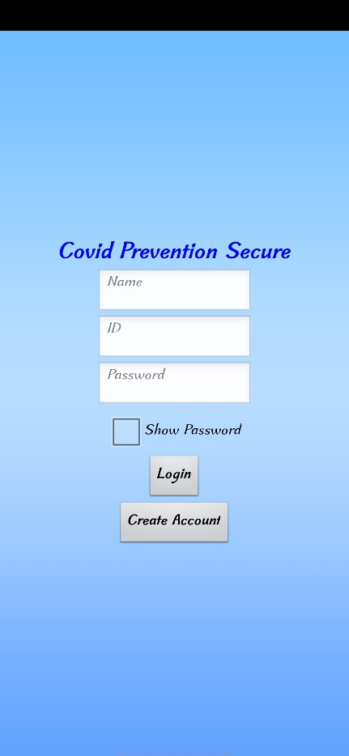 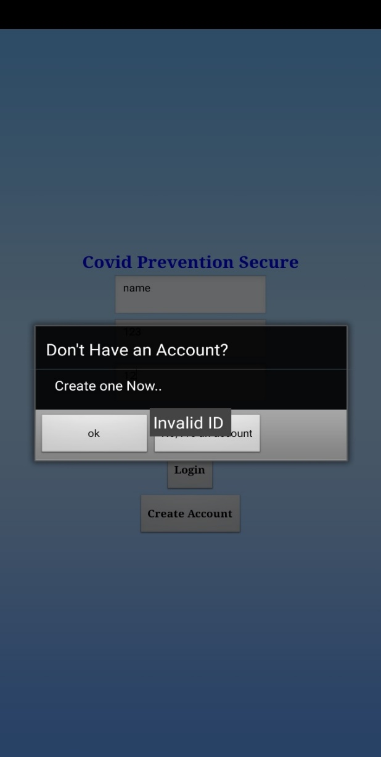

Fig 6.1-Login Page Fig 6.2-Create Account Prompt

* Figure 6.1 Shows that the First Page of the Application LOGIN Page’
* Figure 6.2 Shows that the User doesn’t have an Account in the Application and getting an Instruction that to Create an Account
* We’ve to Create an account with Proper Details if we’re using the app for first time

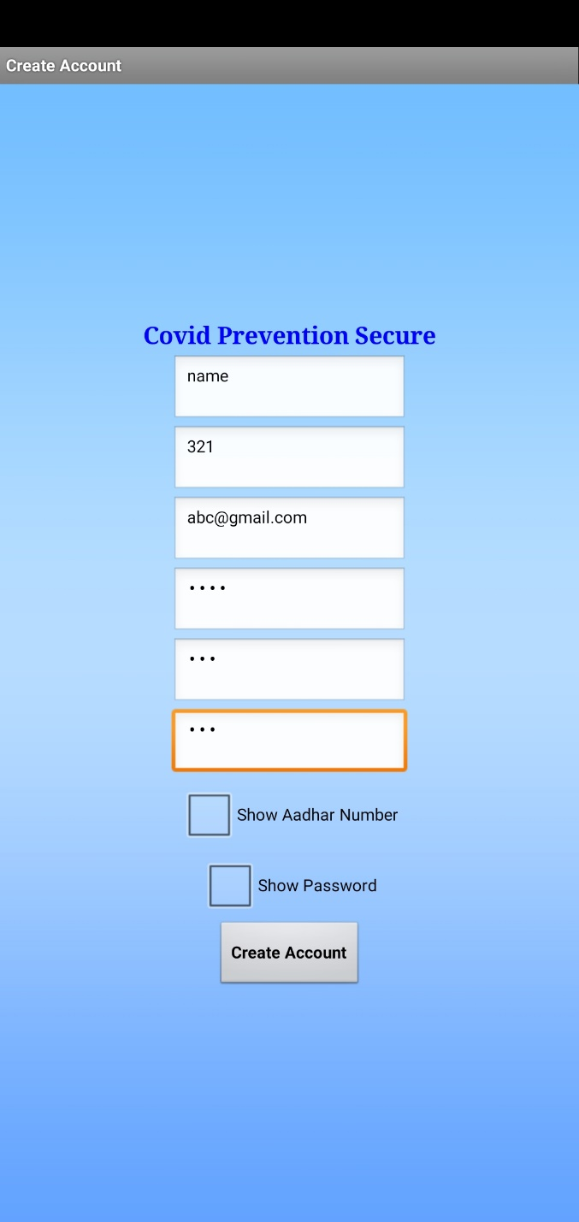 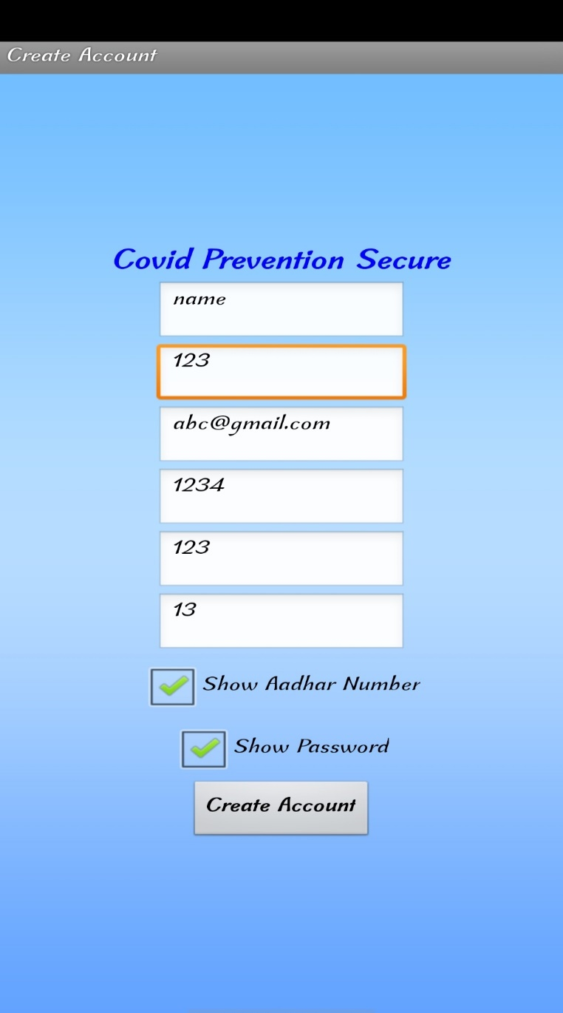

Fig 6.3-Create Account Fig 6.4- Show Confidential Text

* Figure 6.3 Shows that User can Create an account by giving the proper information
* Figure 6.4 Shows that User can see the Confidential Information to cross check once
* We can hide or unhide the confidential sections like password and Aadhaar number

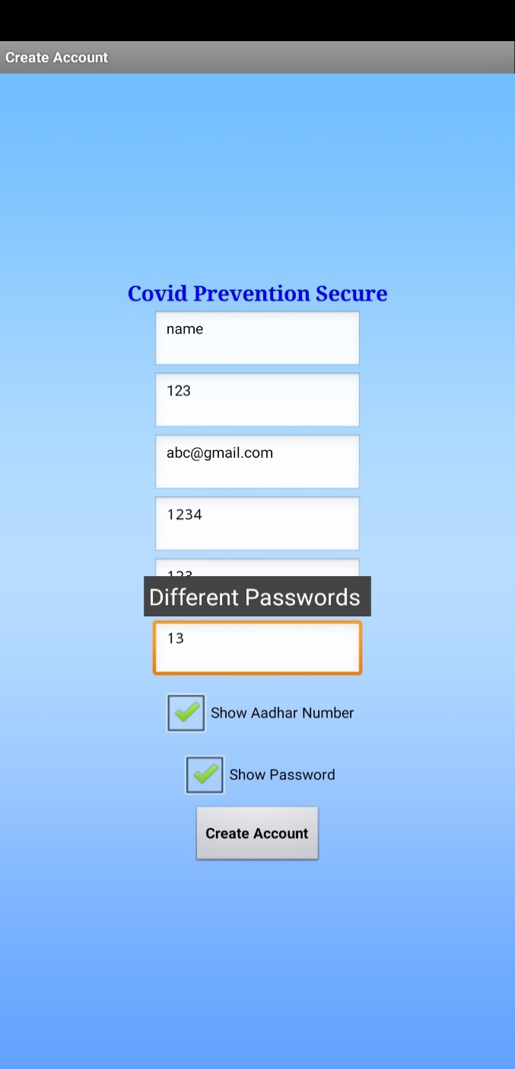 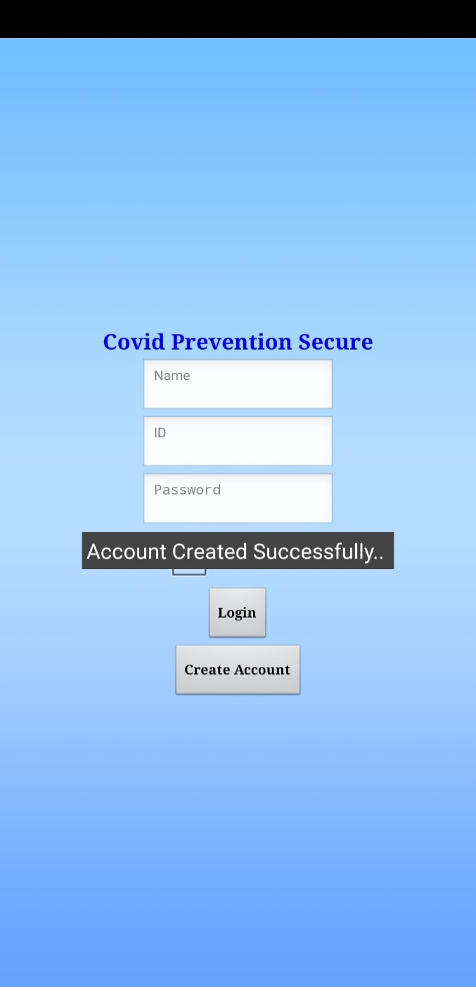

Fig 6.5-Passwords Ambiguity Fig 6.6-Account Created Popup

* Figure 6.5 Shows that Passwords must be matched in Password Dialg Box and Confirm Password Dialog Box
* Figure 6.6 Shows that Account has been Created Successfully with Proper Infomation
* All Fields must be Filled Properly according to their criteria

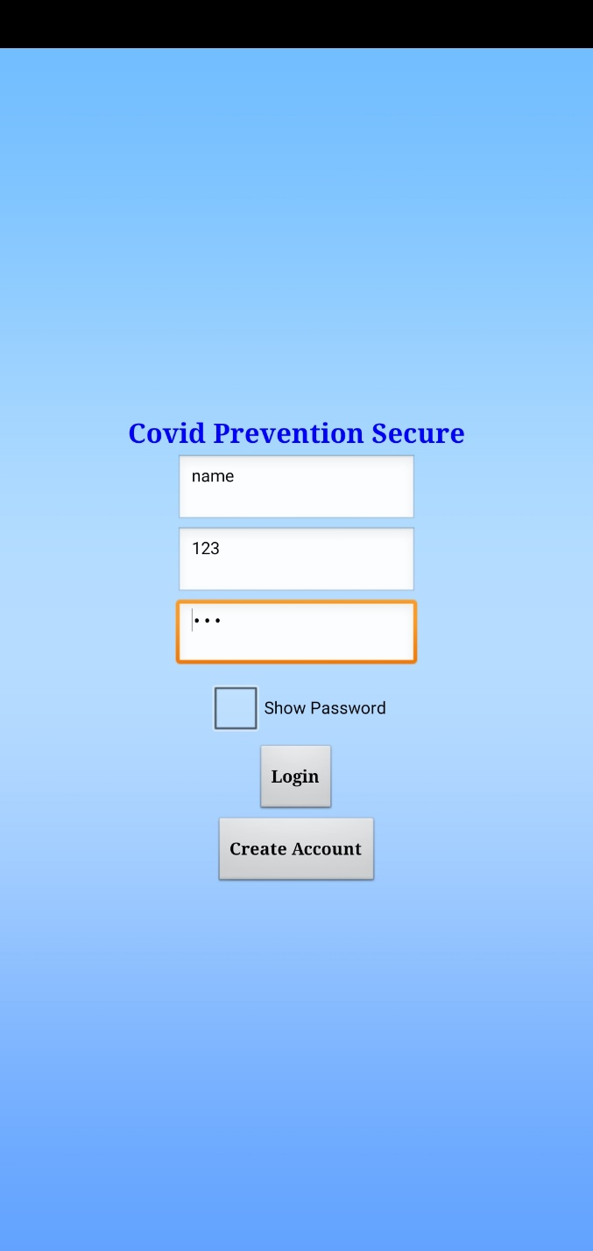 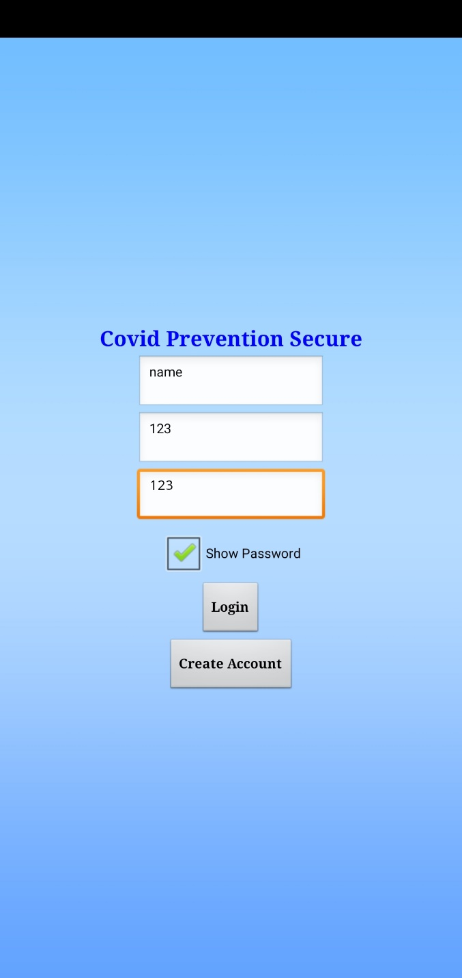

Fig 6.7-Login Page Credentials Fig 6.8-Show Encrypted Password

* Figure 6.7 Shows that User have to Fill the Details which are given in the Account Creation Page
* Figure 6.8 Shows that User can crosscheck the Password by viewing it by checking the Show Password CheckBox
* All Fields must be Filled Properly according to their criteria

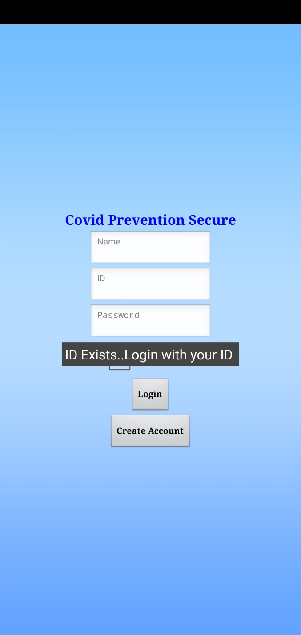 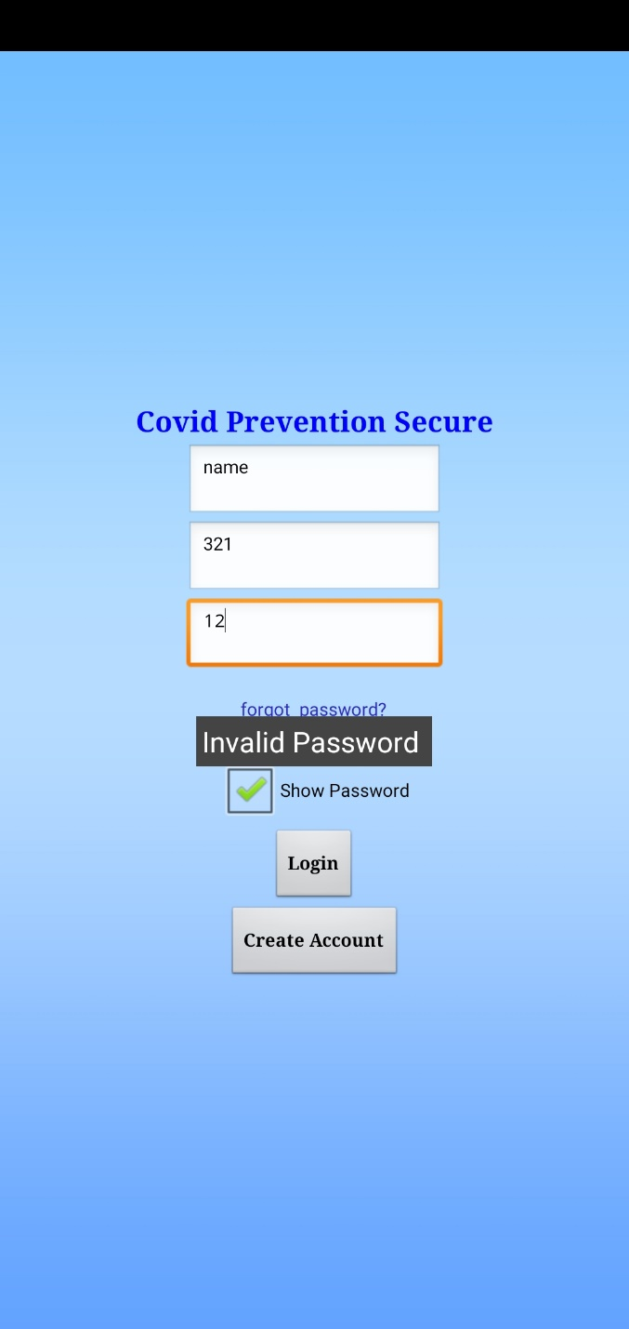

Fig 6.9-Existed Account Fig 6.10-Wrong Password

* Figure 6.9 Shows that If account already exists it’ll show a popup that ID Exists
* Figure 6.10 Shows that User will get a Popup when he Entered a Wrong Popup
* We have to enter Valid Information to login
* We can show and hide the password by checking the checkbox

 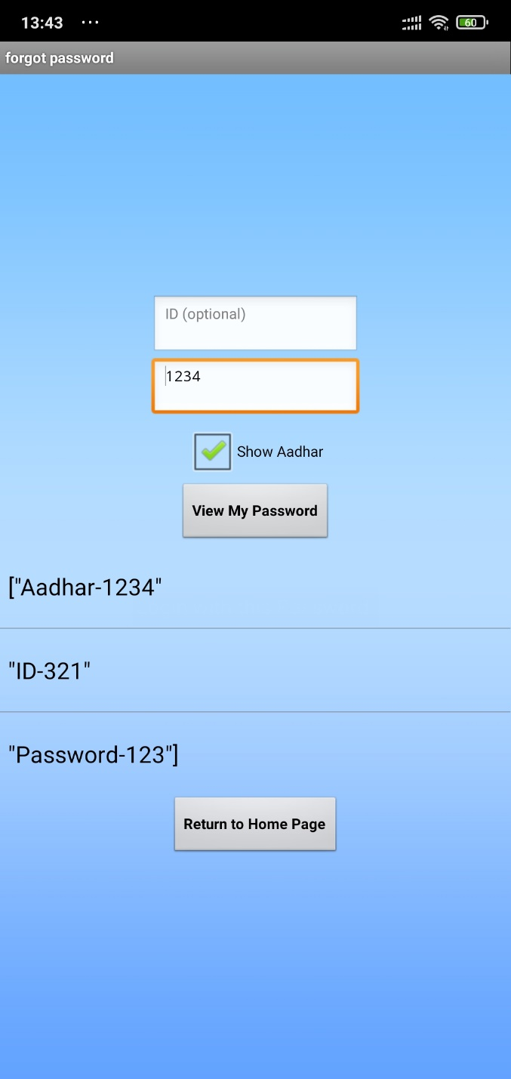

Fig 6.11- Password Incorrect Popup Fig 6.12-Password Check

* Figure 6.11 Shows that User Entered Incorrect Password and User gets an option Forgot Password which that option will help the user to Check the Password by giving a valid proof number known as Aadhar Number where it’ll be unique for all
* Figure 6.12 Shows that User can Recheck the Password by giving Aadhar Number
* If we forgot the password, the forgot password option will be shown and we can check the password with Aadhar number

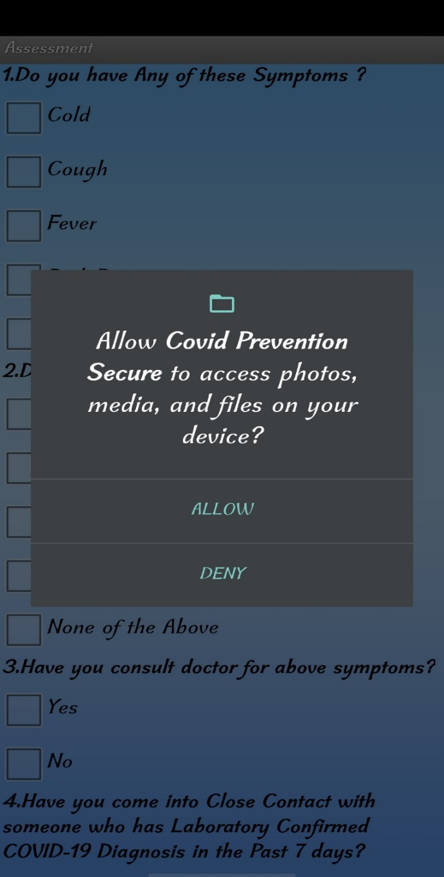

Fig 6.13 – Storage Access

* Figure 6.13 Shows that Application needs to store some health data into the device storage where the Health Analytics and User Health Data will be Stored in a xlsx format file and Retrieves it whenever the user needed
* The Storage Access File is a File Component which stores and Retrieves the File data from the Secondary Storage

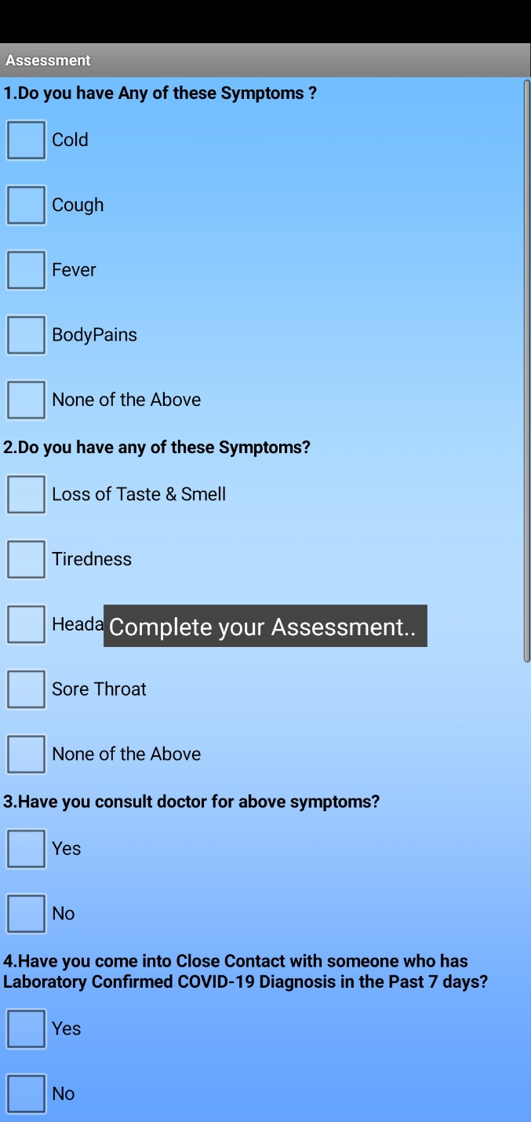 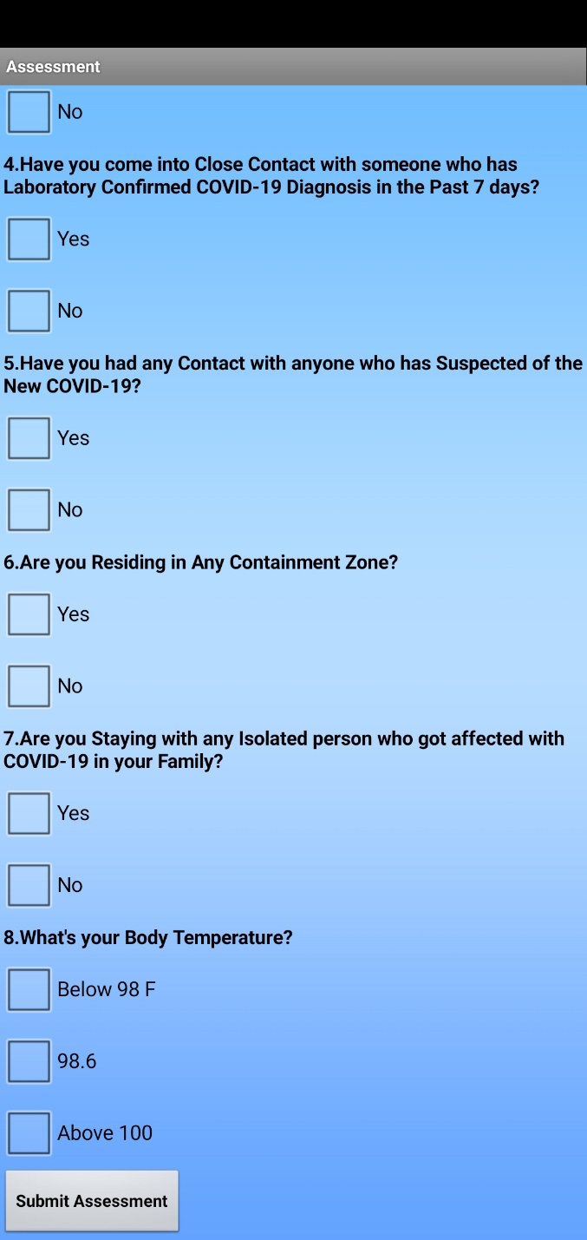

Fig 6.14 – Assessment

* Figure 6.14 Shows that User have to Complete the Assessement According to the Health status of the User
* After Login we’ll get Assessment page
* Complete the Assesment by checking options

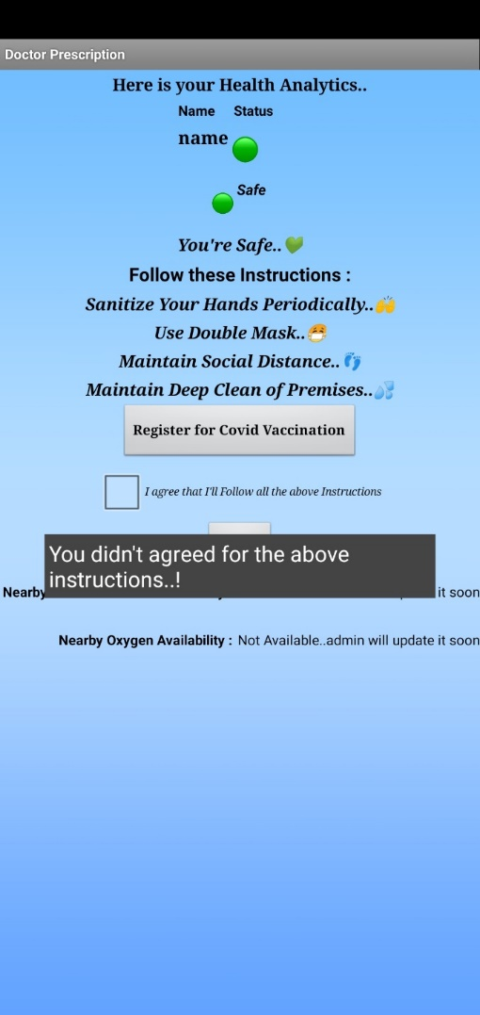 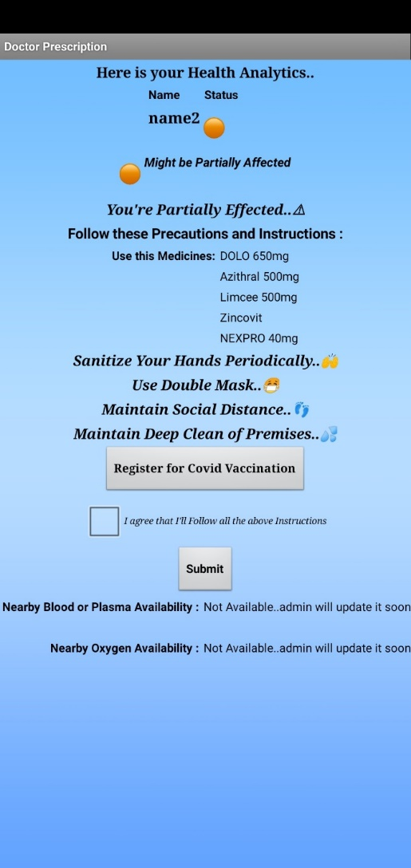 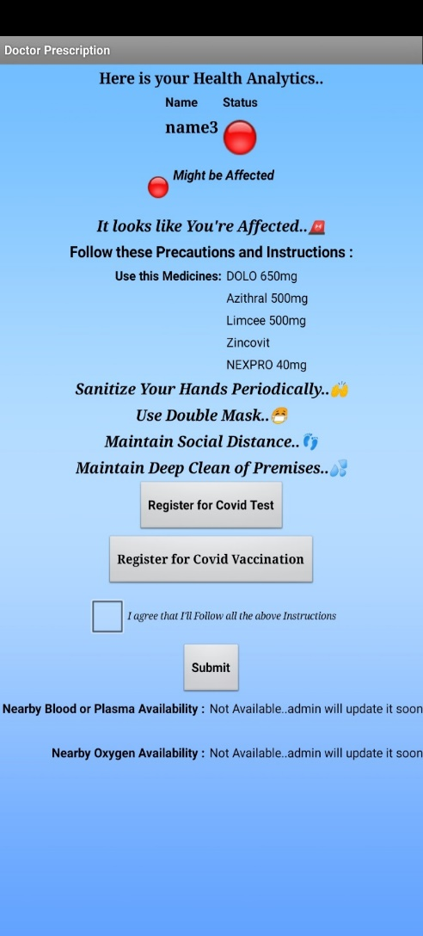

Fig 6.15 – Result with Green Fig 6.16 – Result with Orange Fig 6.17 – Result with Red

Indication Indication Indication

* Figure 6.15 Shows that User got Indicated with Green color as the user is in Safe State
* Figure 6.16 Shows that User got Indicated with Orange color as the user is in Partially Affected State
* Figure 6.17 Shows that User got Indicated with Red color as the user is in Affected State
* According to Assessment the user will get a color as - Red – Might be Affected

Orange – Might be Partially Effected

Green - Safe

* We can go through the Covid Test and Covid Vaccination Options to avail Services
* We have to check the box that we’ve to agree the instructions & precautions

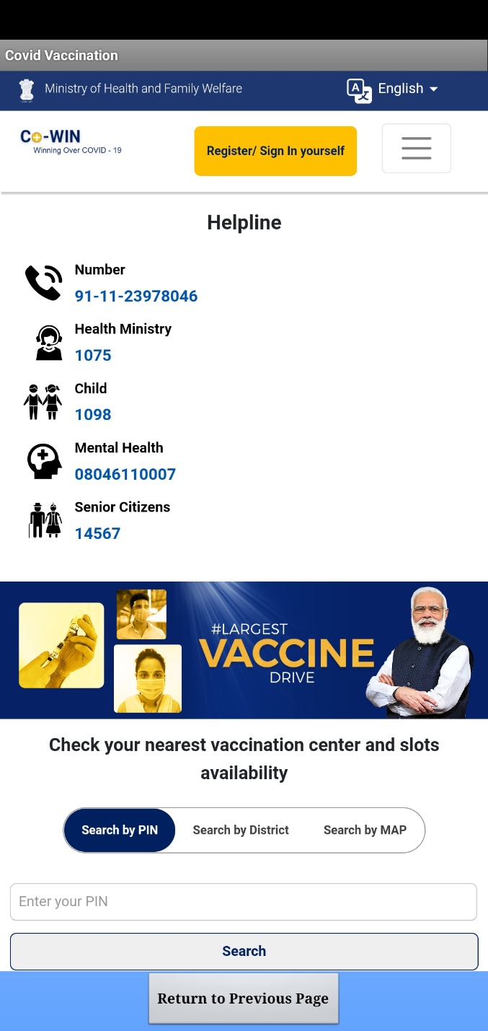 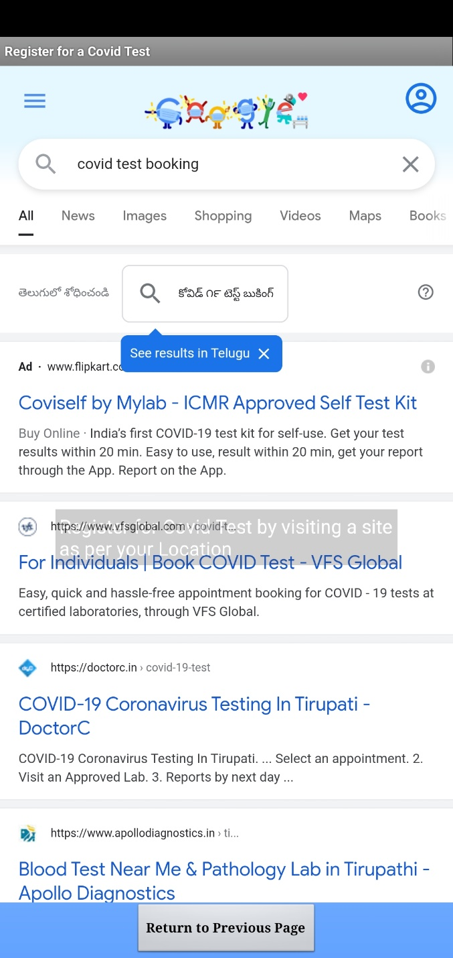

Fig 6.18 – Covid Vaccination Registration Fig 6.19 – Covid Test Registration

* Figure 6.18 shows that User can Register to the Covid Vaccination in this app
* Figure 6.19 Shows that User can Register for a Covid Test in this app
* We can book a Covid Test and Covid Vaccination by clicking on the buttons

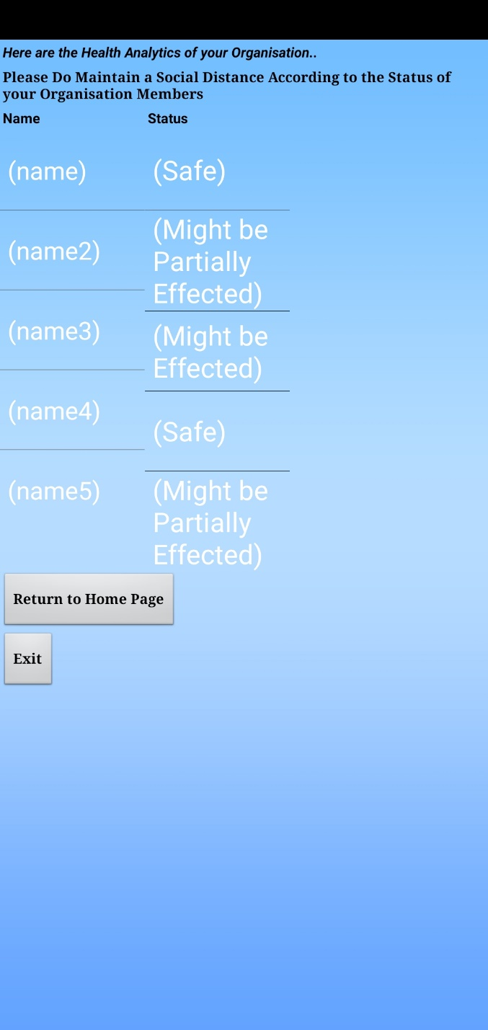

Fig 6.20 – Health Analytics

* Figure 6.20 Shows that User can see the Whole Organisation’s Health Status Report
* With this Report the User can Maintain a Social Distance to the People to avoid spreading of COVID

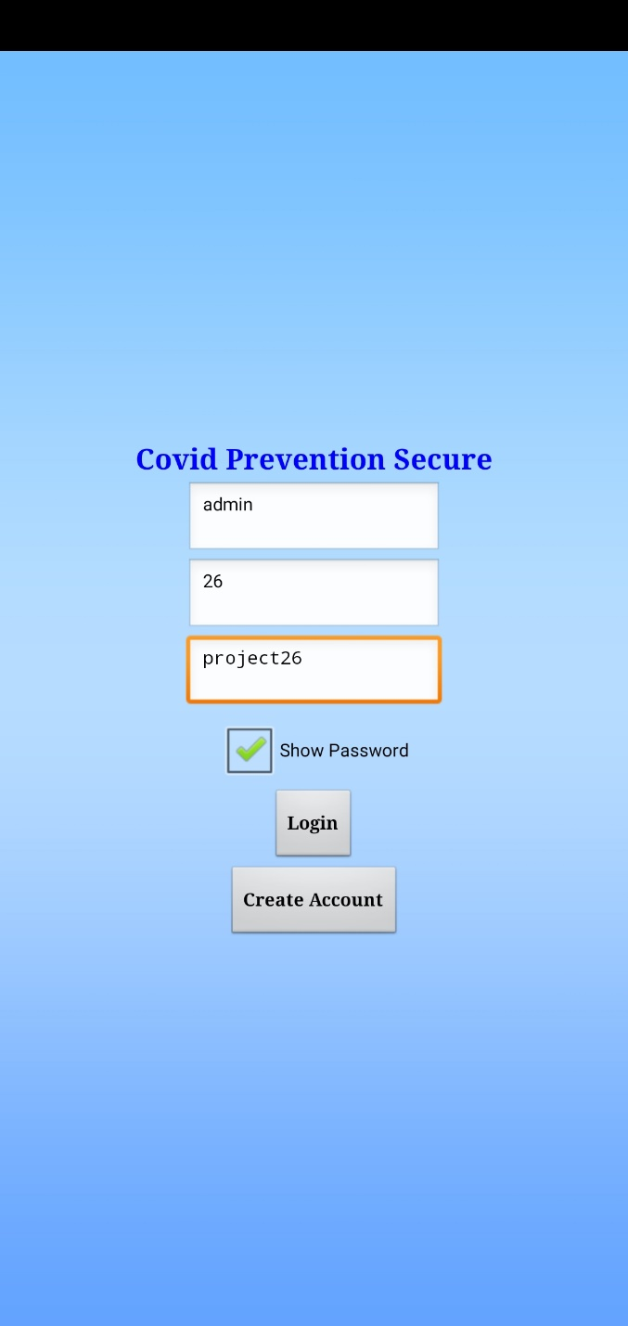 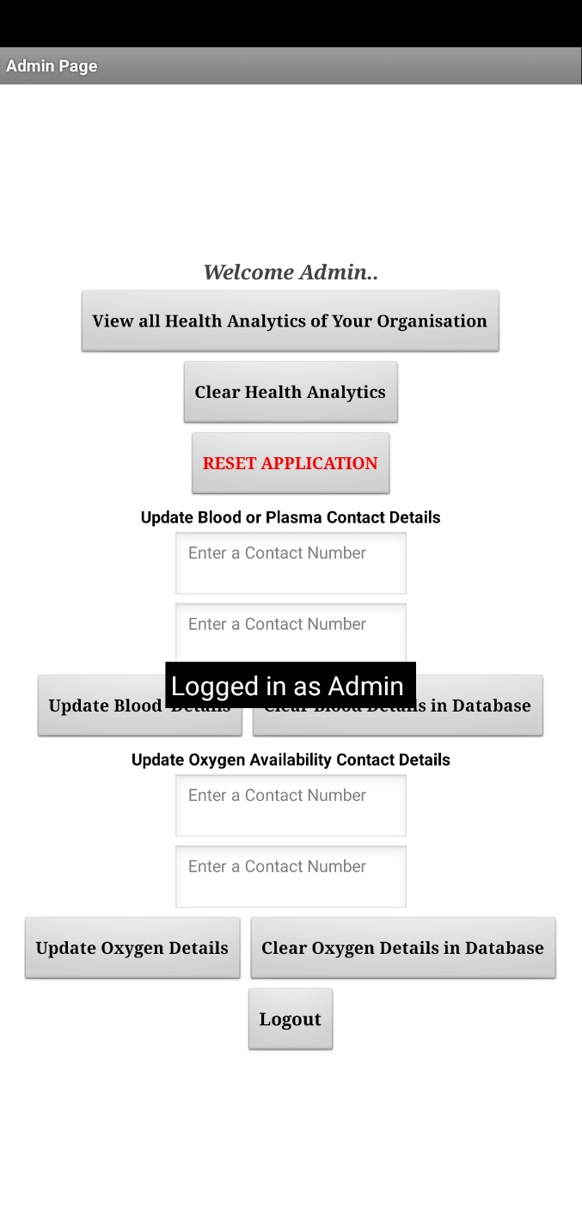

Fig 6.21 – Admin Login Fig 6.22 – Admin Logged In Popup

* Figure 6.21 Shows that with admin login credentials we can login into the admin page .
* Figure 6.22 Shows that when the Admin has Logged In Successfully, the user will get a popup that Logged in as Admin

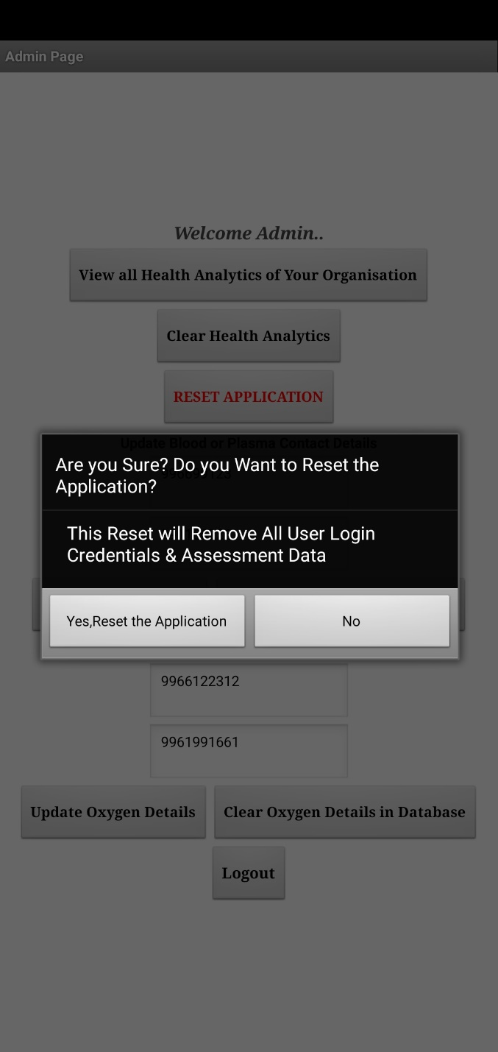 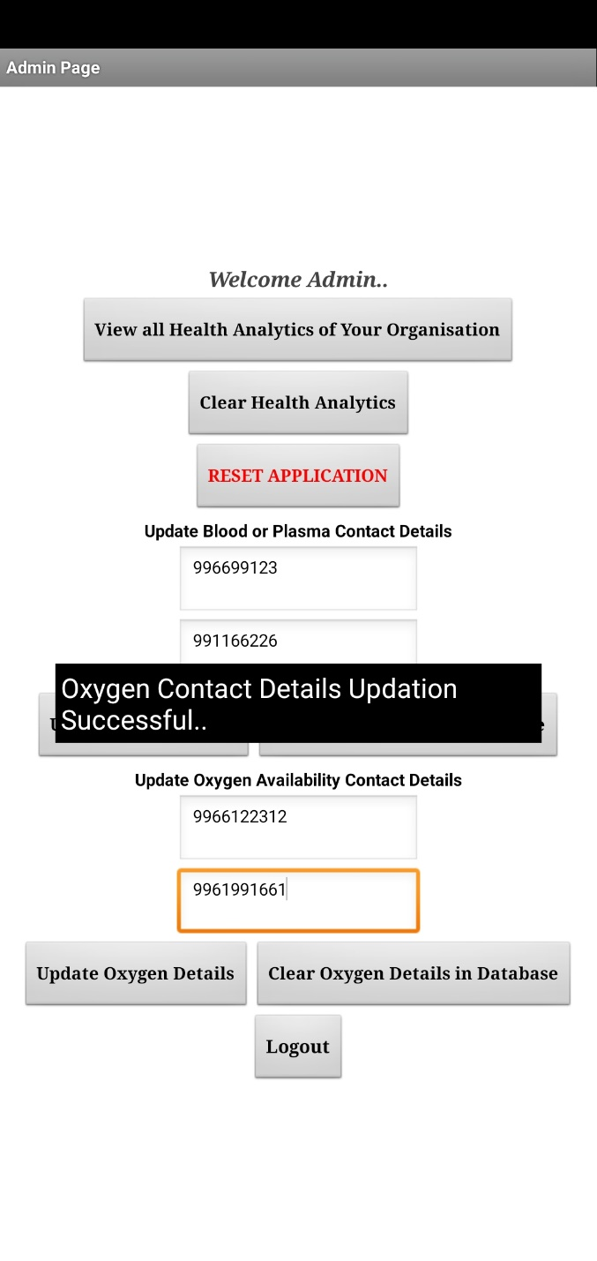

Fig 6.23 – Reset Application Fig 6.24 – Contact Updation

* Figure 6.23 Shows that The Admin can Reset the Application and can view the Health Analytics of their Organisation
* Figure 6.24 Shows that the Admin can update the Blood or Plasma and Oxygen contact details in app

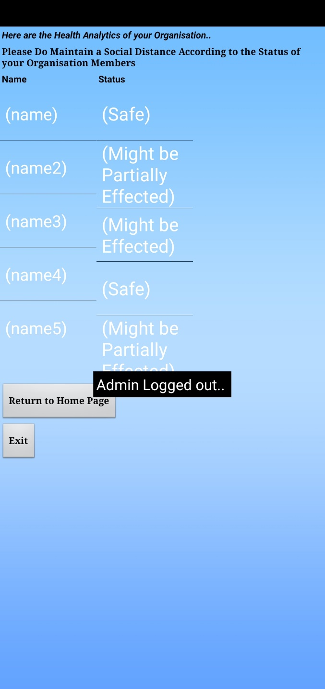 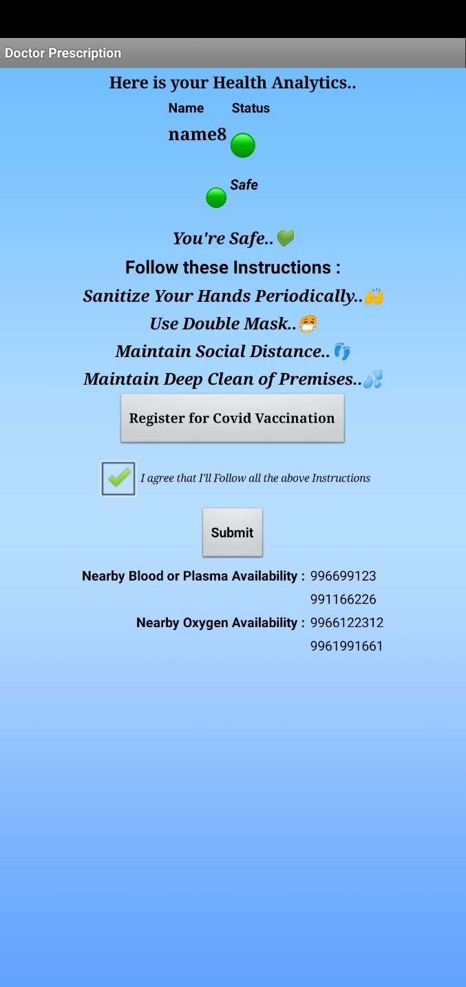

Fig 6.25 – Health Analytics in Admin view Fig 6.26 – After Contacts Updation

* Figure 6.25 shows that Admin can check all the Health Analytics of his Organisation without taking any Assessment
* Figure 6.26 Shows that Application data will be changes when Admin Made any changed in the Admin Panel
* Everyone can see the Blood and Oxygen details once admin Updates the Data of Blood and Oxygen

**FUTURE SCOPE**

On Upcoming Future Updates we’ll implement this application to use it for everyone through internet and maintain everyone in social distancing by using Bluetooth sensor technology. And also we’ll implement that admin can save and print everyone’s assessment result data and their health status in an excel sheet or PDF format.

**CONCLUSION**

From this Covid Prevention Secure Project, we can know the health status of the person and also Others Health status in an organization. we can get the Blood/plasma and Oxygen details if required. and Registration for Covid Test and Vaccination and get Doctor’s Prescription, we can get Instructions to Prevent from Affecting of Covid, We can Make Social Distancing by knowing that the Person is maybe Affected as the person is having the Red or Orange Indication which that in the Health Analytics has shown that the person might be affected or Partially Affected. By this we can prevent the Covid-19 virus Spreading by Maintaining social Distance according to their health status.

**REFERENCES**

* <https://en.wikipedia.org/wiki/COVID-19>
* [https://www.cdc.gov/coronavirus/2019- ncov/symptoms-testing/coronavirus-self-checker.html](https://www.cdc.gov/coronavirus/2019-%20%20ncov/symptoms-testing/coronavirus-self-checker.html)
* <https://www.cowin.gov.in/home>
* <https://www.vfsglobal.com/en/individuals/covid-test.html>